**SH6636 Oval (66 x 36)**

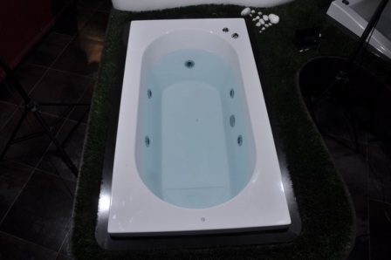

**SH7242 (72 x 42)**

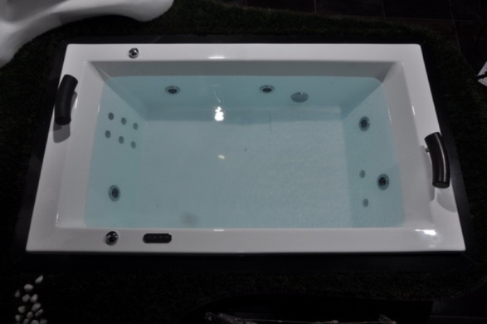

**Hourglass 66 x 36**

